The idea behind this project was for me and my partner to complete a project together in a month by working 1 hour per day. This document details the processes and progress done on each day.

# Day 1 – 04/05/2021 - Brainstorming

The hour on day 1 was spent mostly brainstorming. I knew I had to scope accordingly to the time frame, and I knew I would have to rely on things I know rather than spend time trying to figure out new things.

Eventually, I landed on a very simple idea – controlling a rocket by activating its various thrusters and trying to get it from one point to another. I had made something similar a couple of years ago as a self-assigned challenge to design and develop a game in 4 hours.

By taking this existing concept and expanding on it, I knew we would be able to complete it and make it into a finished, polished product that has the potential to be a fun experience.

Following this decision, I quickly wrote up a loose schedule for the rest of the week in terms of tasks for the project.

|  |  |  |  |  |
| --- | --- | --- | --- | --- |
| Wednesday 05.05 | Thursday 06.05 | Friday 07.05 | Saturday 08.05 | Sunday 09.05 |
| Code movement + documentation | Code fuel + documentation | Visualize feedback + documentation | OFF | Clean up documentation + further project planning |

# Day 2 – 05/05/2021 - Movement

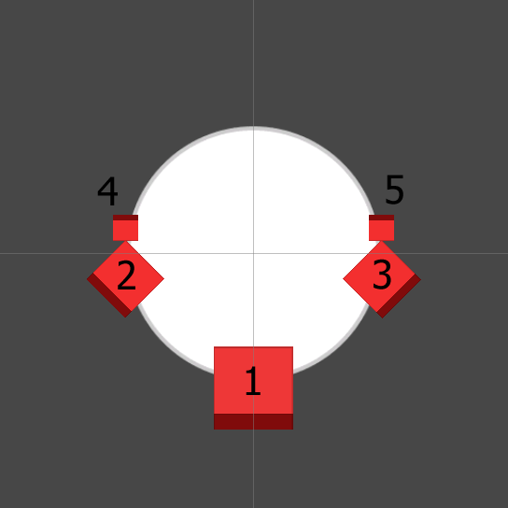The hour on day 2 was spent implementing simple movement for the rocket.

The Rocket has 5 thrusters, shown as red squares on *figure 1*, each with a RigidBody2D component on it, and a Fixed Joint 2D component, attaching it to the RigidBody2D of the Rocket body, shown as white circle.

1. Main Thruster  
2. Left Thruster  
3. Right Thruster  
4. Left Break  
5. Right Break

Using Unity’s new Input System, an action button was assigned to each of the thrusters, as shown on *figure 2.*

Figure 1

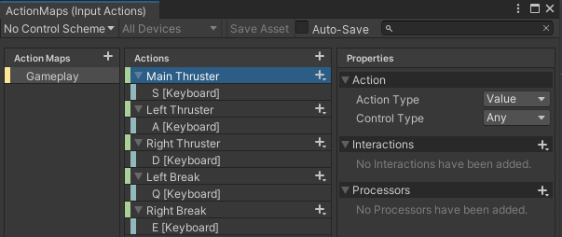Following that, a very simple script was written that checks for input from the action buttons and assigns a value to a variable whenever they are pressed and released, as shown in *figure 3*.

Figure 2

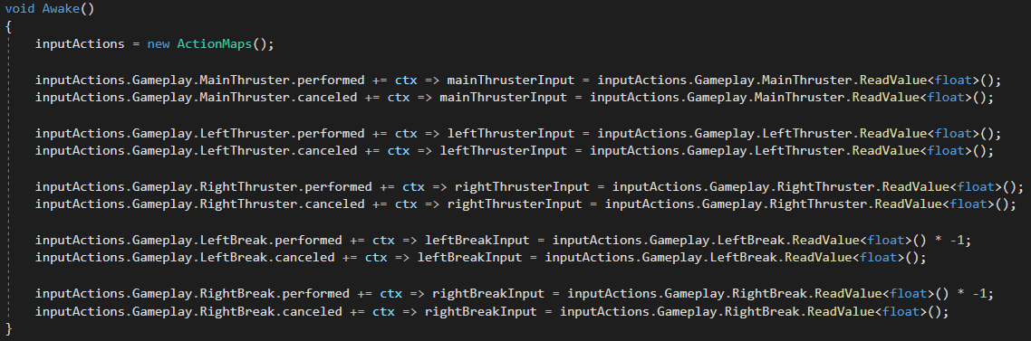

Figure 3

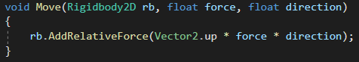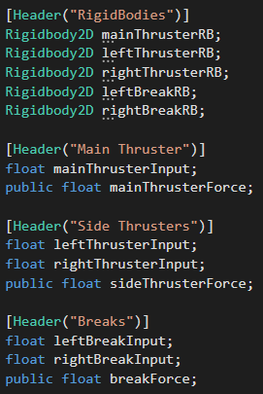The FixedUpdate method then checks to see if any of the input values are not equal to 0, and if so, they pass the relevant variables from *figure 4* into the method in *figure 5,* which applies relative force in the opposite direction of the dark red bit on each thruster, as shown in *figure 1.*

Figure 5

Figure 4

# Day 3 – 06/05/2021 - Fuel

The hour on day 3 was spent implementing the first draft of the rocket art and implementing ‘fuel tanks’ for the various thrusters.

Each element of the rocket was drawn on a separate layer and desaturated. Following that, it was implemented into unity using the PSD Importer Package, as shown on *figure 6.*

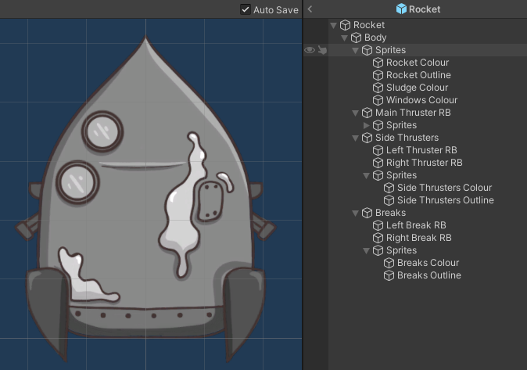

Figure 6

This way the rocket can be re-coloured in Unity at any point during development, avoiding the need to amend the source files in an illustrating software.

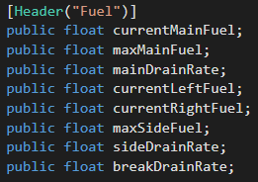Then variables for the fuel tanks were implemented, *figure 7*.

Figure 7

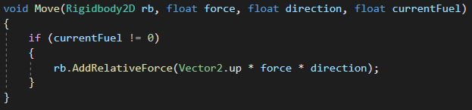The Move method was amended to take the fuel into consideration, *figure 8.*

Figure 8

And the FixedUpdate method was amended to drain the respective fuel whenever a thruster is activated, *figure 9.*

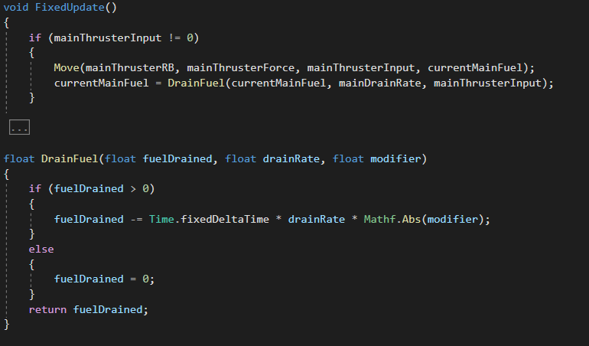

Figure 9

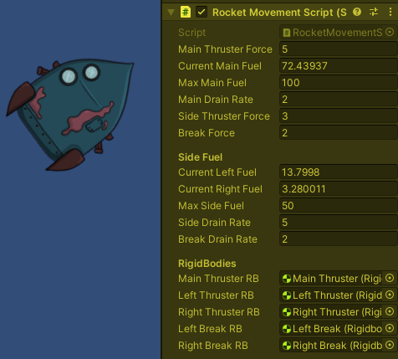

There are 3 Fuel Tanks in total – Main Fuel, Left Fuel, and Right Fuel.

The Main Fuel is used up by the Main Thruster.

The Left Fuel is used up by the Left Thruster and Left Break.

The Right Fuel is used up by the Right Thruster and Right Break.

No Thruster can be used if its respective Tank is empty.

Figure 10

# Day 4 – 07/05/2021 – Particle Effects

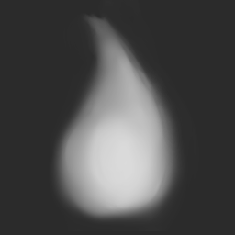The hour on day 4 was spent mostly playing around with Unity’s particle system.

Using CLIP STUDIO PAINT, a flame-like sprite was made which would be used to make engine fire, *figure 11.*

After implementing it into Unity and setting it as the sprite for the particles, the different values were tweaked until it looked somewhat satisfactory, *figures 12 & 13.*

Figure 11

 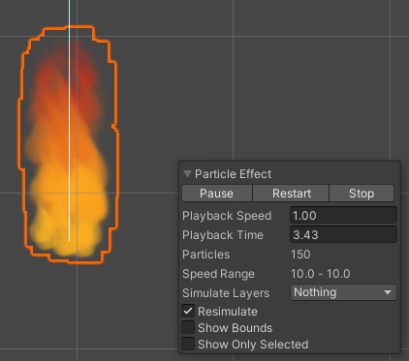

Figure 13

Figure 12

Following that, a particle system was assigned to each Thruster and the Move method was amended to turn it on and off whenever the Thrusters are activated, *figure 14*.

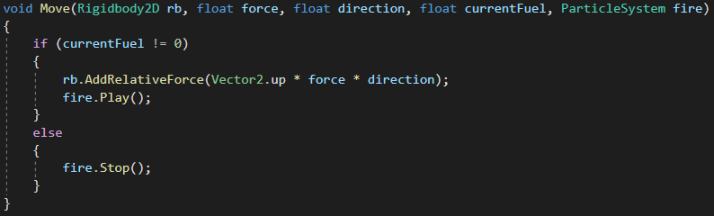

Figure 14

A few lines of code were also added to the Awake method, so the particles would turn off whenever the action buttons were released, *figure 15.*



Figure 15

The result, *figure 16,* provides visual feedback whenever the player presses any of the movement buttons, giving a clear sense of what each does and in what direction they will move the rocket.



Figure 16

# Day 5 – 08/05/2021 - Off

Day off.

# Day 6 – 09/05/2021 – Project Planning

The hour on day 6 was spent preparing a loose schedule for the upcoming week and what tasks should be completed for the project, as well as cleaning up and organising the documentation so far.

|  |  |  |  |  |
| --- | --- | --- | --- | --- |
| Monday 10.05 | Tuesday 11.05 | Wednesday 12.05 | Thursday 13.05 | Friday 14.05 |
| Localized gravity | Art implementation + visualize fuel | Health + collision damage | Respawn + goal platform | Platform spawn + fuel recharge |

# Day 7 – 10/05/2021 – Localized Gravity

The hour on day 7 was spent sorting out localized gravitational pulls.

Initially, a simple script was made that would change Unity’s Physics2D gravity modifier based on angle between the rocket and whatever would be pulling it. That seemed to work relatively okay, however it would have potentially caused issues further down the line when more than one object would have its own gravitational pull.

After a brief research, it turned out the best way to go about this would be with a Point Effector 2D.

Once assigned, the values of the Point Effectors were tweaked until the desired effect was achieved, as visible in *figure 17*.

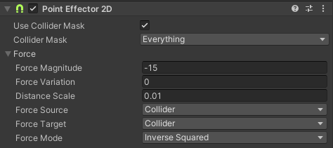The absolute value of the Force Magnitude must be lower than the force of the Main Thruster, so the rocket would be able to take off from the planets.

Figure 1

The Distance Scale must be a relatively low fraction, so the effect can be felt immediately once the rocket enters a gravitational field.

As the planets which will have their own gravitational fields would be static, they will not require a RigidBody2D component, so the Force Source is set to Collider.

Force Target is set to collider as well so torque could be added to the pulled bodies, depending on which part of them touches the gravitational field first.

And the Force Mode is set to Inverse Squared so it mirrors real-life gravity, accelerating exponentially in accordance with the pulled target’s mass.

The final effect offers some challenge for the player while keeping it relatively easy for anyone to pick up, *figure 18.*



Figure 1

# Day 8 – 11/05/2021 – Art Implementation & Fuel Visualization

The hour on day 8 was spent implementing the art assets produced so far and visualizing the use of fuel.

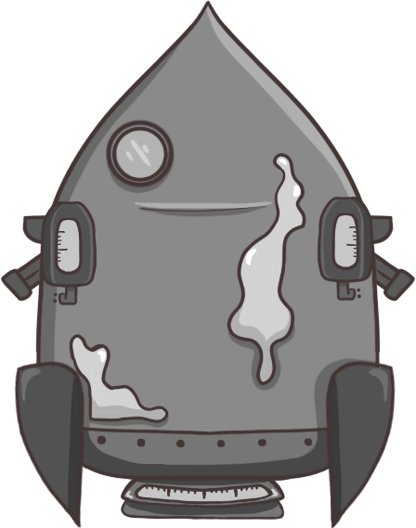The new rocket model has three tanks on it to represent the fuel tanks for the different thrusters, *figure 19.*

Figure 19

In addition to the rocket, a sample planet, a landing platform, and several background elements were implemented into Unity.

With them, a quick scene was set up for testing purposes, as shown in *figure 20*.

Figure 20

Following that, a canvas was set up as a child to the rocket’s body and sliders were made and placed on each of the fuel tanks.

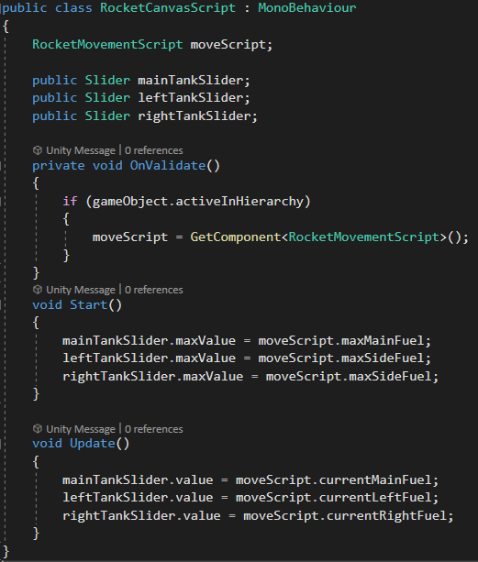A simple script was written to tie the values of the slider to the values of the fuel tanks to visualize them, *figure 21.*

The sliders were then changed to have vibrant colours and the fuel drain rates were bumped up for testing purposes.

The results are visible in *figure 22.*



Figure 22

Figure 21

# Day 9 – 12/05/2021 – Collision & General Improvements

The hour on day 9 was spent writing a simple script to detect collisions and making general quality improvements to the project.

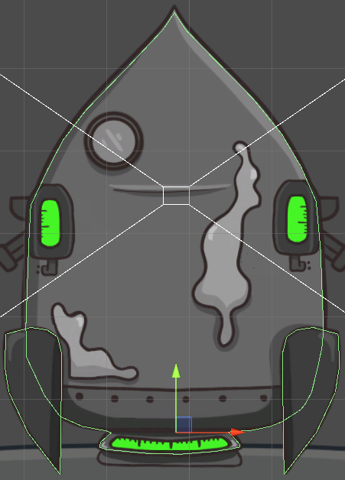First, edge colliders were added to each of the rocket’s legs and another edge collider was put on the rockets body, *figure 23.*

Figure 23

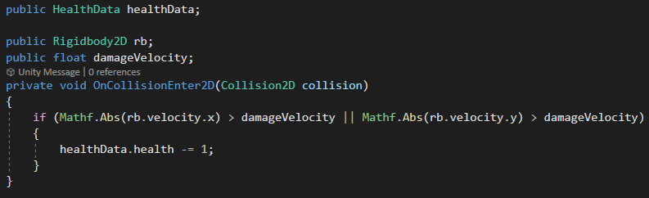A simple script was written and attached to the rocket’s body that looks for collisions at certain velocity, *figure 24.*

Figure 24

Following that, all code written until this point was reworked to use scriptable objects.

This way, future complications could be avoided by eliminating the need to have the scripts reference each other.

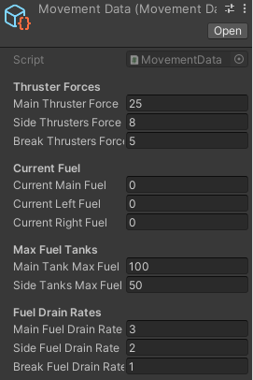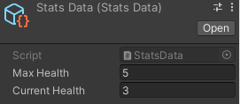Using scriptable objects allows for multiple scripts to interact with the data from them and therefore work independently from one another. The data currently being stored in scriptable objects are the input values, *figure 25*, movement values, *figure 26,* and the health values for the rocket, *figure 27.*

Figure 27

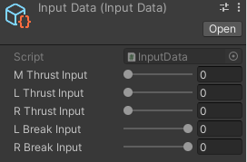

Figure 25

Figure 26

# Day 10 – 13/05/2021 – Last Platform Position & Respawn

The hour on day 10 was spent writing simple scripts that would keep track of the last platform the Rocket was still on and return it there once it collides with something.

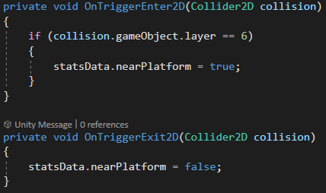First, a Trigger Collider was added to the landing platform on the planet, and a Boolean was added to the StatsData, and logic was scripted to assign a value to it, *figure 28*.

Figure 28

Following that, a GameData scriptable object was made to hold the position and rotation the rocket had when it was still on the last landing platform.

After that, a short script was written that would capture this data onto the scriptable object, *figure 29.*

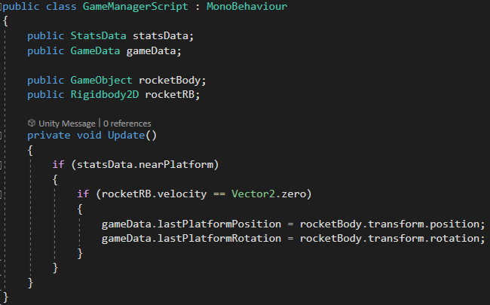

Figure 29

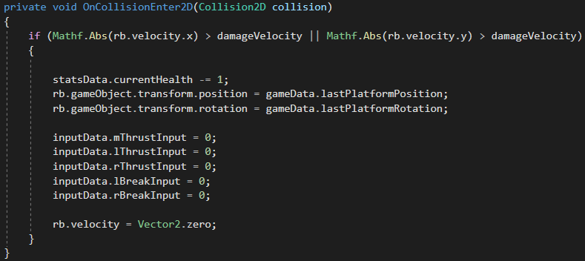Lastly, the Rocket Collision Script was amended to return the rocket to the last platform position and rotation when it collides with something, *figure 30*.

Figure 30

To prevent the rocket from immediately beginning to move after the reset, the input values are reset to 0, as is the rocket’s velocity.

# Graphical user interface, application Description automatically generatedGraphical user interface, application Description automatically generatedDay 11 – 14/05/2021 – Documentation, Design, and Project Planning

The hour on day 11 was spent writing up the documentation for the past couple of days work and then working on general design.

Steering away from the previous plan, today’s workload focused more on documenting all progress made and planning out the future of the project.

With one third of the allocated time for it having passed, it was time to fully consider and plot out the remainder of its lifecycle.

A Trello board was made with all features left to develop and implement, *figure 31.*

No work will be done tomorrow (day 12 – 15/05) because of other responsibilities.

The agenda for Sunday (day 13 – 16/05) will be to plan a working schedule for the remaining 18 days that incorporates everything left from the list above.

# Day 12 – 15/05/2021 – Off

Day off.

# Day 13 – 16/05/2021 – Design & Project Planning

The hour on day 13 was spent polishing the vision for the final product and making an action plan on how to achieve it within the remaining time.

Figure 32

Figure 31

The remaining tasks were broken down and arranged in order for development over the remaining 18 days, *figure 32.*

As it currently stands, everything seems to be on schedule, however the time spent each day working might be increased to 90 minutes due to the increasing complexity of the tasks.